**CMPSC 412 – Lab-9** (25 points)

**Graph Implementation**

**Due date: 3/29/2022**

**Lab Exercises:** Implementing BFS, DFS and Dijkstra’s algorithm

**Exercise:**

1. Draw the graph corresponding to the following adjacency matrix. Attach the screenshot of the image here (if drawn on a paper)

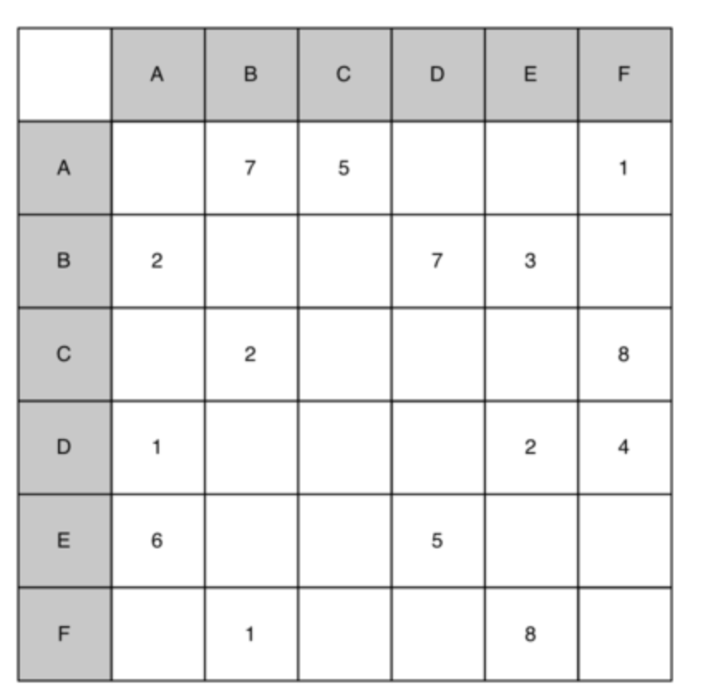

1. Implement the graph corresponding to the following list of edges

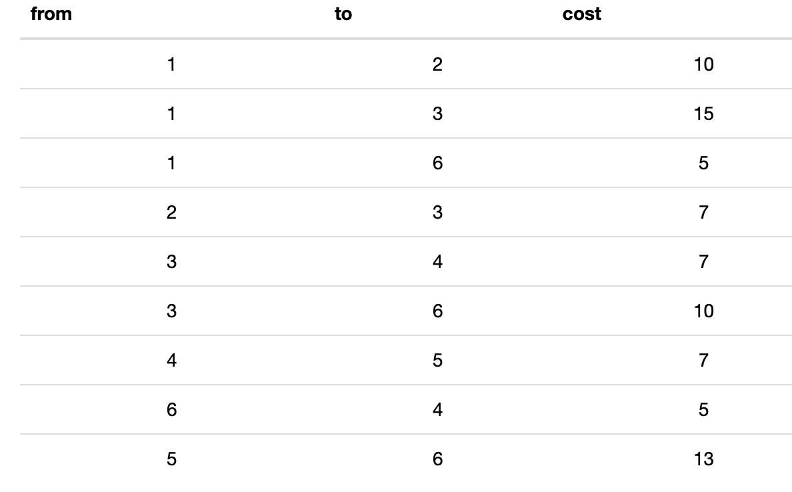

1. Ignoring the weights, implement/perform a breadth first search on the graph from the previous question.
2. Implement/Perform a depth first search for the above graph.
3. Show each step in applying Dijkstra’s algorithm to the graph shown above.